Canon IR C3100/3170

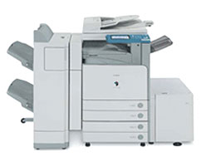 | Features of the Canon IR C 3100/3170  - A Medium duty color enabled black printer.  - 31 ppm in black.  - 7 ppm in color.  - Maximum Paper Weight :170 GSM  - Maximum print size: 12 * 18  - 500 copies per day duty cycle.  - Limitless opportunity for your real world needs.

